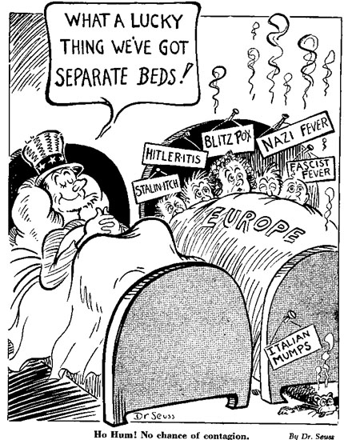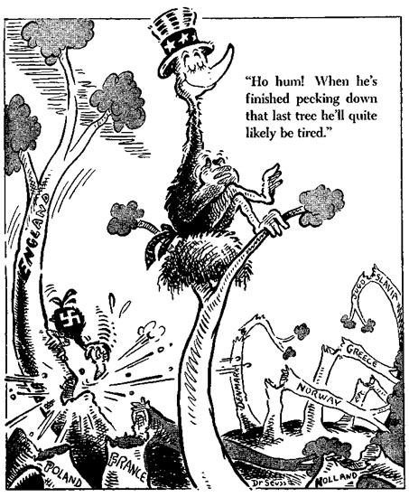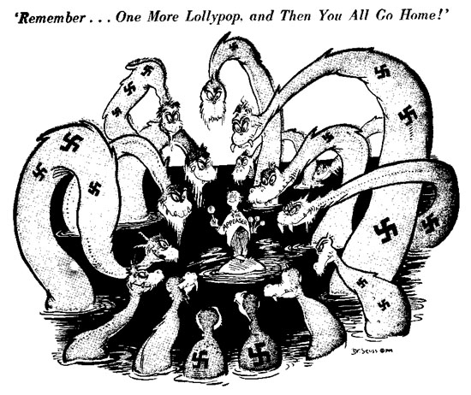
Describe what you see in the cartoon.

How is Germany portrayed in the cartoon?

Which other countries are portrayed in the cartoon? How are they portrayed?

Based on this cartoon, how do you think Dr. Seuss feels about the policy of appeasement? Why?

Cartoon 2
Describe what you see in the cartoon.

What overall message is Dr. Seuss trying to convey in this cartoon?

