North Carolina to Give Some Immigrants Driver’s Licenses, With a Pink Stripe

http://www.nytimes.com/2013/03/06/us/north-carolina-to-give-some-immigrants-drivers-licenses-with-a-pink-stripe.html
The New York Times March 5, 2013

By KIM SEVERSON
RALEIGH, N.C. — In a move some are calling a modern-day scarlet letter and others say is the best way to manage changing federal immigration policy, North Carolina this month will begin giving some young immigrants driver’s licenses marked with a bold pink stripe and the words “no lawful status” printed in red.

The licenses were developed as a way for the state to cope with a quirk in the Deferred Action for Childhood Arrivals program, which the Obama administration began last year to deal with the as many as 1.7 million young immigrants across the country who were brought to the United States by their parents and have been living here illegally since.

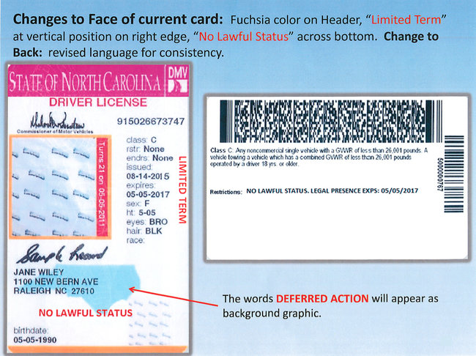
Under the program, young people who qualify receive deferrals from deportation for two years. They are no longer illegal, but they do not become fully legal either.

While the program allows them work permits, many still need to drive to their jobs. So in January, the federal agency that administers the program determined that immigrants with deferrals were just legal enough to qualify for driver’s licenses.

Although a majority of states are issuing the licenses, each is choosing a different path. Ohio officials leave it up to individual motor vehicle offices, although two state senators this week introduced a bill to make the licenses mandatory.

Michigan officials announced last month that they would hand out licenses after first refusing, a move that had brought a lawsuit from the American Civil Liberties Union and the National Immigration Law Center.

The governors of Arizona and Nebraska still will not issue driver’s licenses. In February, national legal rights and immigration groups filed a federal class-action lawsuit challenging Arizona’s position on constitutional grounds.

At first, North Carolina balked, too. When the state’s attorney general ruled in January that the licenses were legal, the state Transportation Department devised what officials believed was a way to thread the needle between opposing factions.

Gov. Pat McCrory, the newly elected Republican, has called the pink-trimmed licenses “a pragmatic compromise.”

But for some of the nearly 15,000 people who have applied for status under the deferred action program in North Carolina, the pink-tinged licenses are humiliating. They say the licenses could set them up for more harassment in a state that, like many, is struggling to cope with changing demographics.

“More than anything, it’s that we are already targeted,” said Jose Rico, 23, whose parents arrived in the United States from Mexico on a tourist visa when he was 13 and have never left.

Mr. Rico is studying engineering at a Durham community college and is part of the N. C. Dream Team, a grass-roots organization of illegal immigrant youth.

He worries that with a pink-striped license he will get harassed at bars, banks and airports — the places where people regularly present a driver’s license without a second thought.

“It says right there you have no lawful status, which is true, but you are giving that to people who do not need to know your status,” he said. “It only opens us up for more harassment.”

On Monday, a group of Democratic legislators introduced a bill to make sure that all driver’s licenses issued by the state were indistinguishable.

“It is offensive to me that the governor would put a stigma upon young people who are legal,” said State Representative Paul Luebke, Democrat of Durham, one of the bill’s sponsors. He is particularly concerned about how the licenses might affect the holder’s job prospects.

“Why should someone who has gone through the process and gotten their papers have to go through hoops to explain to a potential employer exactly who they are because they have a driver’s license with a pink stripe on it?” Mr. Luebke said.

Some Republican lawmakers opposed to issuing any licenses at all to the young immigrants have introduced their own bills, asking that the licenses not be issued until June, by which time they hope to determine if the governor has stretched his constitutional powers.

Members of religious groups in North Carolina have also criticized the state’s decision to issue the licenses.

When Rabbi John Friedman told members of Judea Reform Congregation in Durham about the new licenses at services Friday, he said he heard an audible gasp. He and other clergy members are encouraging their followers to stick a piece of pink tape on their licenses in solidarity and protest.

“It’s punitive,” said the Rev. Richard Edens of the United Church of Chapel Hill. “It just continues a sense of shame and humiliation.”

North Carolina also plans to issue a new generation of driver’s licenses for the entire state by the end of the year. There will be distinguishing marks for other noncitizens, including permanent residents and other visa holders, but it is unclear whether the pink stripes will continue, said Greer Beaty, a spokeswoman for the Transportation Department.

Julia Preston contributed reporting from New York.

