C&E Unit 2 Textbook Questions Name:
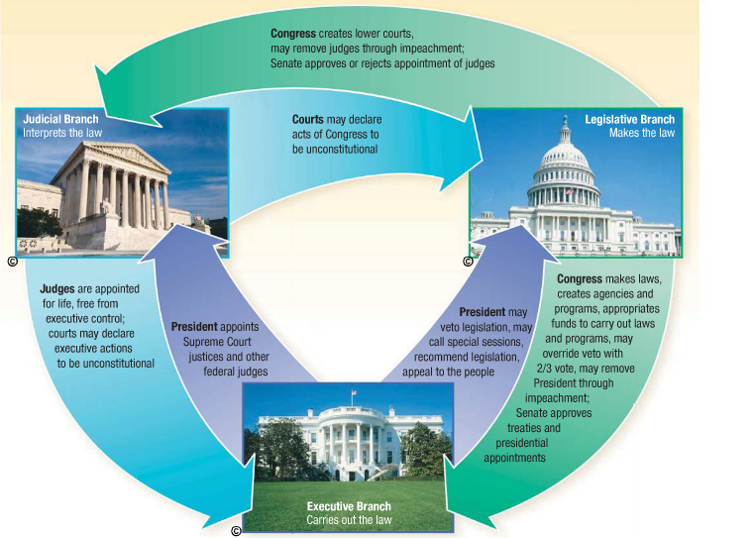
Overview of Executive, Legislative, and Judicial Branches

1) Last summer most of the Affordable Care Act (also known as Obamacare) was declared constitutional. Who passed the law in the first place? Who found it constitutional? Whose job is it to make the law happen? (Use this chart – also found on p. 68 to see the job of each branch.)

Legislative branch | Executive branch | Judicial branch
_____________ the laws | _____________ the law | determines if the law follows the ___________.
The main group or person in this branch is ____________________ | The main group or person in this branch is ____________________ | The main group or person in this branch is ____________________
What did this branch have to do with Obamacare? | What did this branch have to do with Obamacare? | What did this branch have to do with Obamacare?
The powers of this branch can be found in Article ___ (p. 758) | The powers of this branch can be found in Article ___ (p. 758) | The powers of this branch can be found in Article ___ (p. 758)

2) Articles IV-VII
Article IV:
What is the Full Faith and Credit Clause? Give an example (p.106)
Article V:
What is the most common way to amend the Constitution? Be sure to explain 2/3 and 3/4 in your answer (72)
Article VI:
What is the Supremacy Clause? Give an example. (94)

4) (291-292) What is meant by strict interpretation vs. loose interpretation of the Constitution? Give an example in your answer as well. (Your textbook uses slightly different terms:
liberal construction = loose interpretation, strict construction = strict interpretation)

5) Amendments to the Constitution
Why was it important that the authors of the Constitution include an amendment process? (p. 72)

