Review Packet—WWI and WWII Test
Instructions: Complete the questions below. Completing this packet will be 20 points of your total grade on the test. In other words, if you don’t complete this, the highest grade you can receive will be an 80%. If you are off-task during class today, Ms. Cooper will take your paper and you will lose your chance to get any of these points.

- Define and explain the significance of the WWI terms below:
  - MAIN causes of war (make sure you know what they are, what each one means, and how each one contributed to WWI)
  - Franz Ferdinand
  - Schlieffen Plan
  - Treaty of Versailles (Who takes part? Who is left out? What are the terms (parts)? What are the consequences of these terms?)
- Name 5 new technologies and explain how they changed war.
- Write 3 sentences describing trench warfare. Then, write 2 sentences describing the war’s effect on soldiers.
- Label the Allied and the Central Powers on the map below.
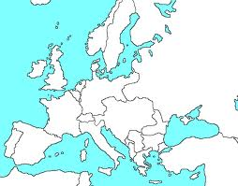

- How do the Allied Powers change in 1917? (2 ways)
- Define and explain the significance of the Russian Revolution terms below:
  - Tsar Nicholas II
  - Bolsheviks
  - Vladimir Lenin
  - Joseph Stalin
- What is capitalism? Give an example of a country with a capitalist economy.
- What is communism? (Need good, detailed, thorough explanation) Give an example of a country that was communist during WWII.
- How was Lenin’s communism different from Marx’s communism?
- What type of leader was Joseph Stalin?
- What is fascism (good, detailed, thorough explanation)? Name four countries that were fascist during WWII?
- What is hyperinflation? Why did it happen in Germany?
- Why did many people turn to fascist or communist beliefs during the 1930s?
- Why was the League of Nations so reluctant to act against aggressive countries in the 1930s?
- Look at the Dr. Seuss political cartoons (linked on my website) that we saw earlier. For each of the 3 cartoons, describe the picture, explain how countries/events are portrayed, and explain Dr. Seuss’s message to the viewer.
- For each of the WWII terms below, define/explain the significance:
  - Appeasement
  - Sudetenland
  - Munich Conference
  - Nazi-Soviet Nonaggression Pact
  - Invasion of Poland
  - Phony War
  - Maginot Line
  - Battle of Britain
  - Hitler’s invasion of USSR
  - Japan bombs Pearl Harbor
  - Battle of Stalingrad
  - Invasion of Normandy (D-Day)
  - Mussolini
  - Hitler
  - Stalin
  - FDR
  - Churchill
  - Hirohito
- Who were the main Allied Powers at the beginning of the war? How does this change in 1941?
- Who were the three main Axis Powers?
- Label the countries on the 1939 map below. Also, label the Atlantic Ocean and the Mediterranean Sea. For the test, you should be able to label all the major countries involved in the war.
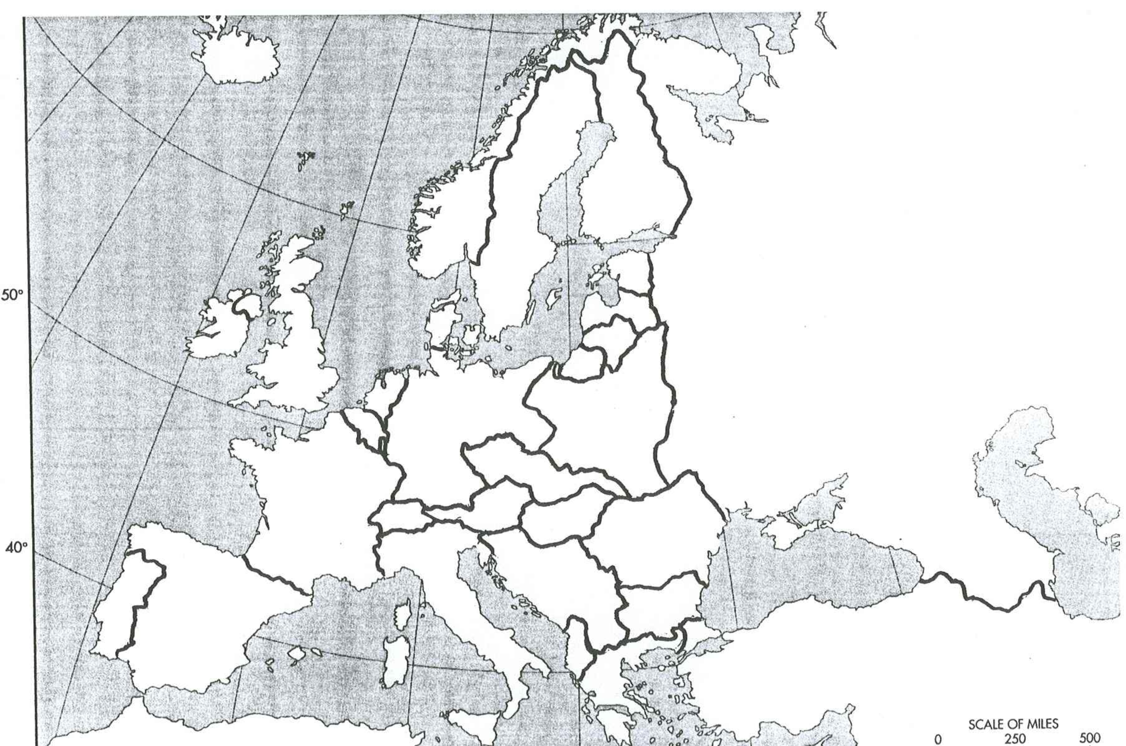
- Describe the abuses Jews endured during the Holocaust (think about the images we saw in class) in 3-4 sentences.
- What is the difference between anti-Judaism and anti-Semitism?
- How had Jews been historically persecuted in Europe? Why were they targeted?
- What were the four main stages of the Holocaust? Use 2 sentences to describe each (8 sentences total). How do the 8 stages of genocide correspond to these specific stages of the Holocaust?
- Which non-Jewish groups were persecuted during the Holocaust?
Review Questions: Imperialism (This topic will also be included on the test)
- What is imperialism?
- Which time period are we discussing when we talk about imperialism in this class?
- Give two examples of countries that are taken over by other countries during this time period. Describe the experience of each of the two countries in 2-3 sentences.
- Look back over the imperialism political cartoons (linked on my website—there are four of them) and describe each. Be able to explain the historical event depicted in each.
- Give five specific reasons European countries practiced imperialism and explain each.

