**Careers in Psychology**

http://psychology.massey.ac.nz/images/phrenology-b.gif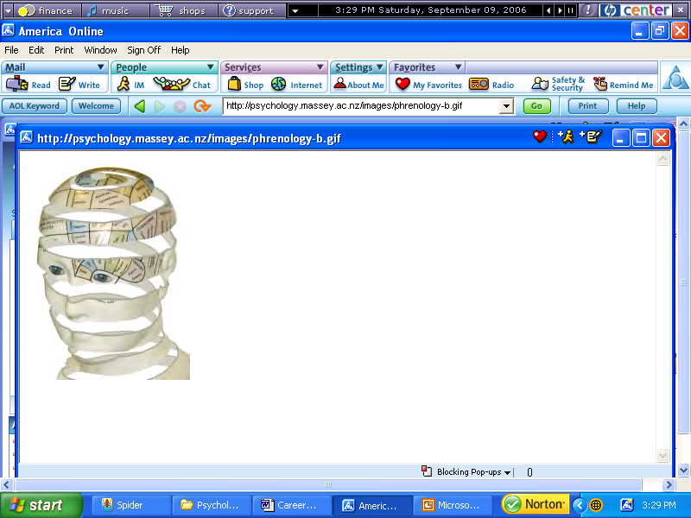[http://images.google.com/images?q=tbn:e15M7yIofZxrBM:http://psychology.massey.ac.nz/images/phrenology-b.gifhttp://images.google.com/images?q=tbn:e15M7yIofZxrBM:http://psychology.massey.ac.nz/images/phrenology-b.gif](http://images.google.com/imgres?imgurl=http://psychology.massey.ac.nz/images/phrenology-b.gif&imgrefurl=http://psychology.massey.ac.nz/&h=250&w=187&sz=25&hl=en&start=3&tbnid=e15M7yIofZxrBM:&tbnh=111&tbnw=83&prev=/images%3Fq%3Dpsychology%26svnum%3D10%26hl%3Den%26lr%3D%26ie%3DUTF-8)



**WebQuest**

**Introduction:**

There are literally hundreds, maybe even thousands, of jobs within the field of Psychology and new ones are being created every day

How do you figure out which careers you might like to try? It takes some thought, creativity, and research. In the following exercise you will have the opportunity to learn about yourself and careers found within the psychology field.

Begin by reading through the components of the WebQuest to see what will be required.

**The Task:**

You will research a career in a specialized area of psychology and write a profile on this area in pamphlet form. This project is worth **30 points**

Choose one career **in psychology** that you want to learn more about. Some examples include :

* Sports psychology
* Clinical psychology
* Neuropsychology
* Forensic psychology
* Educational psychology
* Community psychology
* Industrial/organizational psychology

This list is not exclusive; there are many other specialties you can investigate.

For the career you have selected, find the answers to the questions on the Careers Worksheet (on my website). Type your answers and submit them to me. Then use the information you have gleaned to create a pamphlet designed to inform prospective psychology majors about a career in the specialty. The pamphlet should be creative, attractive and factual. It should be designed to not only inform, but also to “sell” the career.

**The Resources:**

Go to [Careers in Psychology](http://www.apa.org/topics/psychologycareer.html) . This is the website of the APA. Start here and read about Careers for the Twenty First Century. There are many other websites you can use. Here are a few to get you started:

|  |  |
| --- | --- |
| [Careers in Psychology](http://www.apa.org/topics/psychologycareer.html) |  |
| [U.S. Department of Labor Bureau of Labor Statistics --Occupational Outlook Handbook](http://stats.bls.gov/oco/) |  |
| [Careers in Psychology and Mental Health](http://psychologyinfo.com/students/careers.html) |  |

**What to Turn In:**

1. Careers Worksheet with complete answers to the required questions.
2. A pamphlet designed to profile your chosen specialty for prospective psychology majors.

**Evaluation:**

1. Your pamphlet should be accurate, complete, and artistically/creatively designed. It will be graded using the [Pamphlet Rubric](pamphlet%20rubric.doc).

**Good Luck on your Quest!**

