**The Constitutional Convention and the Men Who Were There Webquest**

*“It appears to me…little short of a miracle, that the Delegates from so many different States…in their manners, circumstances, and prejudices, should unite in forming a system of national Government.”*

*–George Washington*

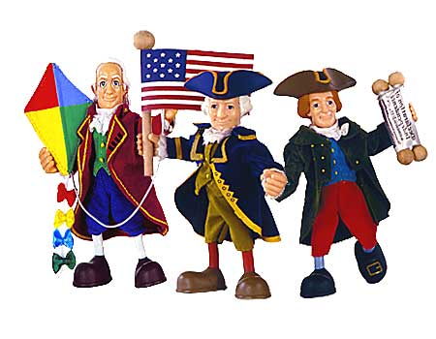**You will be conducting a webquest on the Constitutional Convention and the men who participated the debating and signing of the Constitution. The goal in completing the webquest is to fully understand the procedures and processes that took place at the Convention in Philadelphia. You will also find out which delegate you are most like and how that person was influential at the Constitutional Convention.**

* 1A) Go to: <http://constitutioncenter.org/foundersquiz/>
* Take the **“Which Founder Are You?”** quiz.

You are: _________________________________________

1B) Read the description of your founder and summarize – what’s your founder like?

* 2) Go to: <http://teachingamericanhistory.org/convention/>
* Click on the **Interactive Painting Scene of the Constitutional Convention.**
* Find your delegates name on the painting and answer the following questions about him by clicking **“Learn More.”**

1. What state is your delegate from?
2. What type of job did your delegate perform?
3. What is your delegate wearing in the Howard Christy’s painting?
4. What committees was your delegate a part of?
5. From the biographical reading, was your delegate a supporter of the Constitution? List a few reasons why he was or was not a supporter of the new form of government for America.