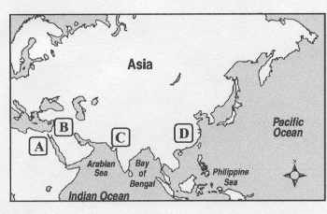

Draw, Shade, and Label: the 4 river civilizations (China, Egypt, India, Mesopotamia) and the rivers they surround (Euphrates, Indus, Nile, Tigris, Yellow)

Draw, Shade, and Label: the 4 river civilizations (China, Egypt, India, Mesopotamia) and the rivers they surround (Euphrates, Indus, Nile, Tigris, Yellow)

