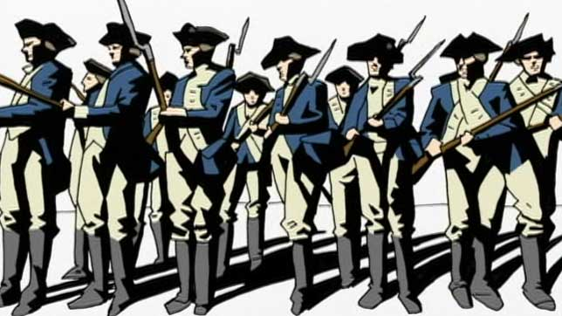
Shay’s Rebellion Questions
Answer these questions on the Shay’s
Rebellion Video. Write the answers
In your notes in a way that restates
the question.
- Why was Daniel Shays upset?
- Who held political power in Massachusetts?
- What was the occupation of many of Shays’ supporters?
- What was happening to state governments in the 1780s? Why wasn’t the federal government able to help with this problem?
- What happened to the courts in Massachusetts following Shays’ march?
- How many followers did Shays have?
- What did Henry Knox want George Washington to do?
- Why was the federal government unable to help Massachusetts end the rebellion?

Shay’s Rebellion Questions
Answer these questions on the Shay’s
Rebellion Video. Write the answers
In your notes in a way that restates
the question.
- Why was Daniel Shays upset?
- Who held political power in Massachusetts?
- What was the occupation of many of Shays’ supporters?
- What was happening to state governments in the 1780s? Why wasn’t the federal government able to help with this problem?
- What happened to the courts in Massachusetts following Shays’ march?
- How many followers did Shays have?
- What did Henry Knox want George Washington to do?
- Why was the federal government unable to help Massachusetts end the rebellion?

