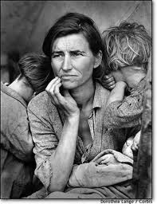
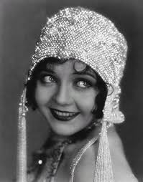
Unit 7: Prosperity and Depression

- Explain the connection between Prohibition and organized crime.
- What was the Great Migration? Name 2 events that happened as a result of the Great Migration.
- What was the Red Scare? Name 2 events that reflected the fears of people during the Red Scare.
- What happened on Black Tuesday?
- Name 3 causes of the Great Depression.
- What was the Bonus Army? What happened to it?
- What were the guiding principles of FDR’s New Deal? (3 Rs)
- What were the causes of the Dust Bowl?
- How did traditionalism and modernism clash in the 1920s?
- What was the major issue of the Scopes Monkey Trial?
- Why was the Model T Ford an important development?
- What was the name of FDR’s plan to end the Depression?
- What was the Agricultural Adjustment Act? Why was it so controversial?
- What happened to the Agricultural Adjustment Act? What did FDR do in response?
- Whose presidency was known for its scandals? Which was its most famous scandal?
- How did FDR’s beliefs about the role of government differ from Hoover’s?
- Describe FDR.
- What happens during a bank run? How did FDR try to prevent them from happening again (both in the short-term and the long-term)

Know:
Quotes we’ve talked about in class
Images we’ve seen in class
Campaign slogans we’ve seen in class
Major legislation
Vocabulary

