World History Supply List
- 3 ring binder
- pencils or pens
- Composition book
Example: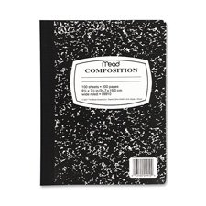
- Index cards
- Loose-leaf paper
Each day, you will need to bring your binder, pencils or pens, loose-leaf paper, and a fully-charged computer to class. This is a part of being prepared each day.

World History Supply List
- 3 ring binder
- pencils or pens
- Composition book
Example:
- Index cards
- Loose-leaf paper
Each day, you will need to bring your binder, pencils or pens, loose-leaf paper, and a fully-charged computer to class. This is a part of being prepared each day.

